Seed Suppliers supplying Open Pollinated seeds

As a gardener, you’ll have bought packets of seeds from gardencentres and online. The seeds will either be “open-pollinated” or “F1”

F1 seeds are created by professional and commercial plant breeders, often international. They are first-generation hybrids from crossing two distinct parent plants, creating offspring with enhanced traits like vigor, yield, uniformity (size, shape, maturity), and disease resistance, making them popular for commercial and home gardening for reliable results, though seeds saved from them won't "come true" in the next generation and usually cost more due to complex breeding. This means you need to buy F1 seeds each year.

Open-pollinated plants are varieties that are naturally pollinated by wind, insects, or self-pollination, resulting in seeds that consistently produce offspring (plants) very similar to the parent plant ("true to type") year after year, allowing gardeners to save seeds and preserve beneficial traits. These plants have greater genetic diversity and adaptability than hybrids, enabling them to evolve and thrive in specific local conditions, often forming the basis for heirloom seeds. This means you can save your seeds to use next year.

Both F1 and open-pollinated seeds have their place in our gardening. I’d like to promote the seed suppliers which supply only organinc, open-pollinated seeds. They tend to be smaller organisations, even individuals, who propogate plants themselves, and save seeds from plants that grows for them in the UK, in their locality. Some of these, such as Beans and Herbs and Real Seeds, have been selling seeds for decades, while others, such as Ellen Rignell at Winnow Farm, have only been around for a year or so. Between them they provide seeds for vegetables, herbs and flowers with associated advice on growing, harvesting and especially - seed-saving. Some of their seeds have been prize-winners at the Wellow Show!

Here are my favourites

Name | Location | Good things about them
Winnow Farm  https://www.winnowfarmseeds.co.uk | Dorset  DT6 5NR | Prize-winning Maravilla de Verano lettuce
Vital Seeds  https://vitalseeds.co.uk/ | Devon  TQ13 7NF | Locally adapted seeds, support a sustainable, diverse food system
She Grows Veg  https://shegrowsveg.com/ | Essex  CO7 6UP | Vibrant colour in everything, and (unusual) heirloom seeds.
Walws Seed Hub  https://www.seedhub.wales | All over Wales | A co-operative of growers in Wales.
Beans and Herbs  https://www.beansandherbs.co.uk | Wiltshire  BA12 7LU | They also have many other flowers and vegetables.
Real Seeds  https://realseeds.co.uk | Wales  SA42 0TS | Lonstanding company, and bolt-resistant Mantovano Fennel
Details on each are below.

Other seed suppliers

Garden Organic and the Heritage Seed Library
Garden Organic, a UK-based charity, is unique for its Heritage Seed Library (HSL), which is a "living library" that holds the UK's National Collection of Heritage Vegetables to safeguard rare varieties from being lost. Unlike a traditional, cold-storage seed bank, these seeds are actively grown and shared with members each year to help them adapt to changing climates and preserve genetic diversity. They are helping gardeners cultivate a healthier, more biodiverse and sustainable world.
https://www.gardenorganic.org.uk

Each year they organise several citizen science experiments that members can participate in. Over the years, these experiments have played an important part in informing the way we grow organically today. We're running 3 experiments this year. You can sign up for our 2026 experiments by clicking on the links below:
- The revival of the Carlin Pea
- Build a better veg planner
- Resilient Greens
https://www.gardenorganic.org.uk/what-we-do/citizen-science-and-research
Anyone interesting in joining in?

Tamar Organics
Tamar Organics is unique for being one of the UK's pioneering companies for offering certified organic seeds since 2000, focusing on encouraging sustainable growing with Soil Association registration, a wide range of organic seeds (veg, herbs, flowers, fruit), composts, and environmentally friendly supplies, supporting biodiversity, and even offering rare heritage varieties, all stemming from their roots as an organic market garden established in 1994.
https://tamarorganics.co.uk

Seed Co-operative - The UK's community-owned organic seed company
What's unique about a Seed Cooperative is its community-owned, democratic structure focused on seed sovereignty, preserving biodiversity, and creating resilient food systems by breeding, sharing, and selling open-pollinated, organic seeds that belong to everyone, directly countering corporate control and promoting local adaptation. Members grow, trial, and save seeds, contributing to a shared pool of varieties. They build local food resilience through community participation, education, and a commitment to ecological farming, making unique seed varieties available.
https://www.seedcooperative.org.uk

Winnow Farm, New House Farm, Broadoak, Bridport DT6 5NR
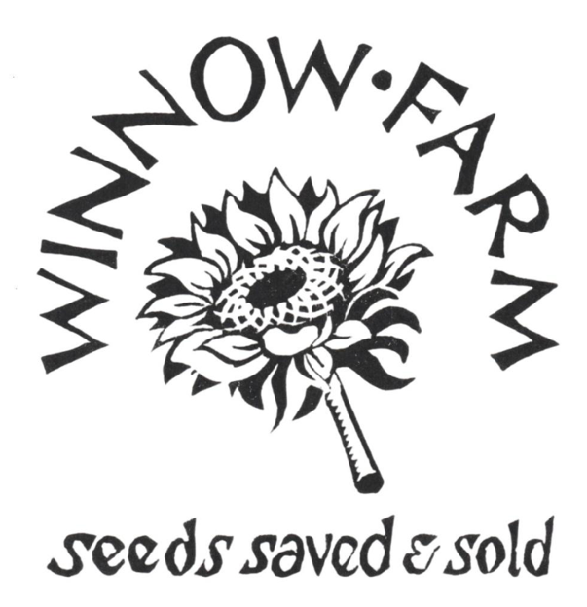
Vegetable, herb and flower seeds
You can expect our seeds to:
Be great quality - we only sell seed with great germination and vigorous seedling growth.
- Be resilient and robust - we only sell vigorous varieties which are adapted to home gardens and thrive in the face of unpredictable British weather.
- Be flavourful (if its a vegetable or herb) - there's nothing more disappointing than going to the trouble of growing your own, only to find the flavour's a bit lacking. Our varieties taste great. We choose them for their culinary qualities and explain how to use them in the kitchen.
- Be beautiful - we only sell cut flower varieties which we think are stunning, and we think our vegetables and herbs are beautiful in their own way too. We share our farm with Emma and Lucy from Meadowsweet Flowers & Floristry who help us thoroughly trial varieties before we put them in our catalogue.
- Be open pollinated - we only offer varieties which you can successfully save seed from. No F1 hybrids here. Open pollinated varieties are genetically diverse and have the plasticity to adapt to our local climate. We think they're the best option for home gardeners.
- Have a story - we connect our seeds back to their seed stewards, telling you a bit about the people and cultures that bred them. Growing food and creating gardens connects us all.

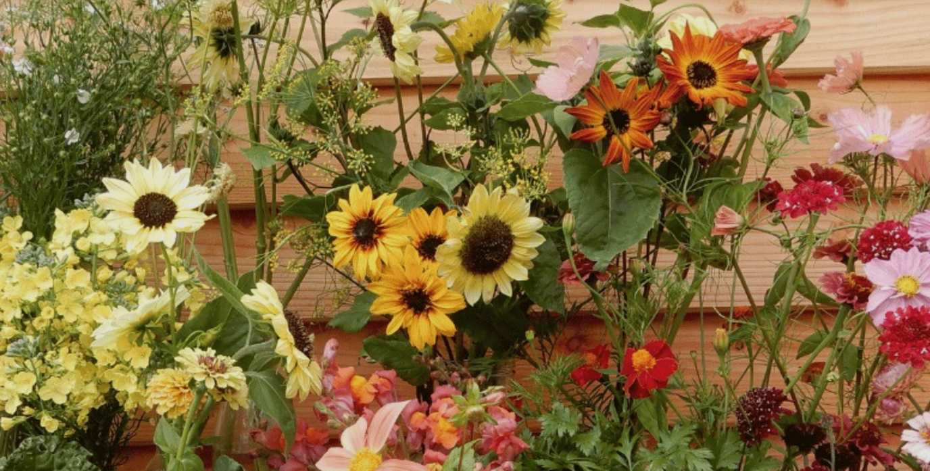
https://www.winnowfarmseeds.co.uk

Vital Seeds, Baddaford Farm, Ashburton, Devon, TQ13 7NF

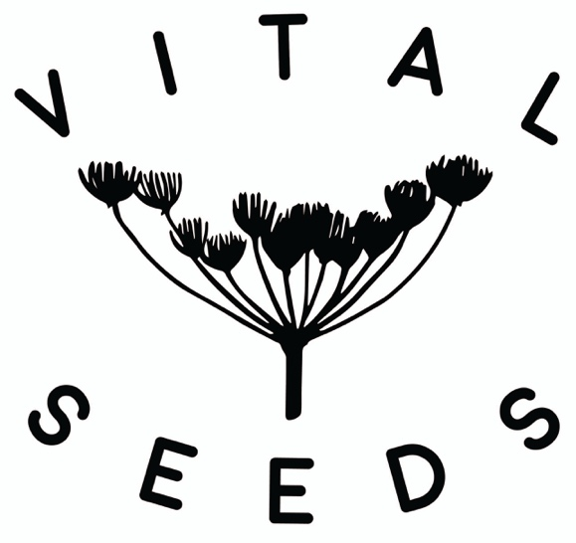
Vital Seeds was founded in 2018, in response to the lack of availability of UK-grown organic and open-pollinated seed. Most of the seed planted in the UK is actually produced many thousands of miles away in countries with a drier climate and cheaper labour. This means that the varieties we grow are unable to adapt to our specific climatic conditions over time. It also means that we do not have control over this vital element of our food system, which we believe is very important. In the last 100 years we have lost 90% of the diversity in our food crops globally, mainly due to the industrialization of the food system and wide-spread use of proprietary F1 hybrid varieties. As all of our seeds are open-pollinated you can save your own seed from them year after year.
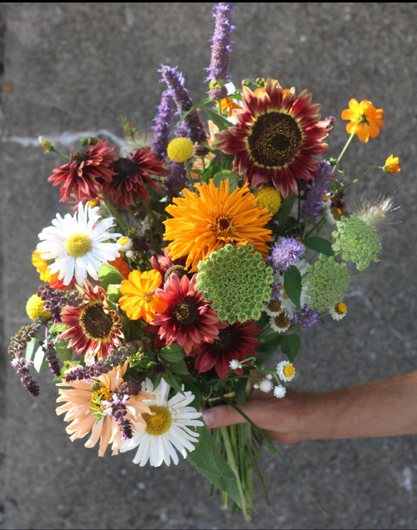
Part of our mission at Vital Seeds is to re-skill gardeners and growers in how to save their own seed, and to revive this ancient and fascinating craft. Follow the links below to find out more. https://vitalseeds.co.uk/growing-resources/
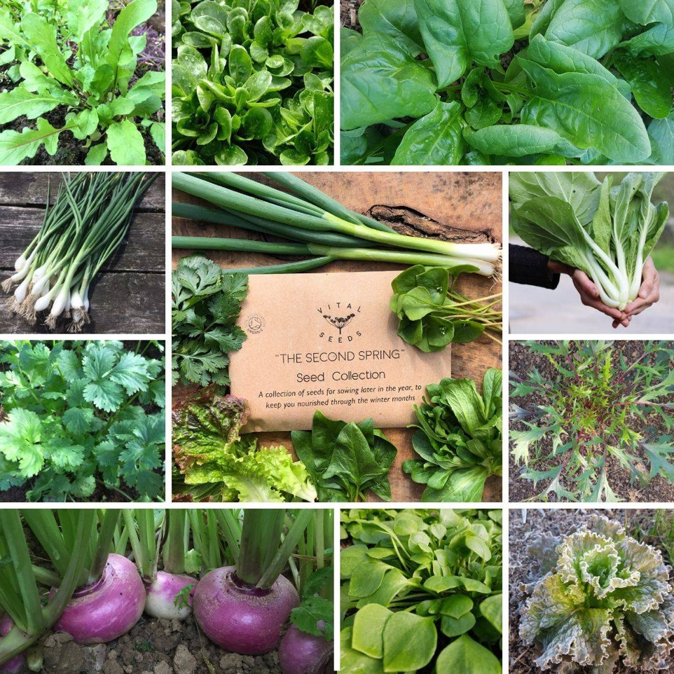
She Grows Veg, East Bergholt Place, Mill Rd, East Bergholt, Colchester, CO7 6UP
For heirloom seeds
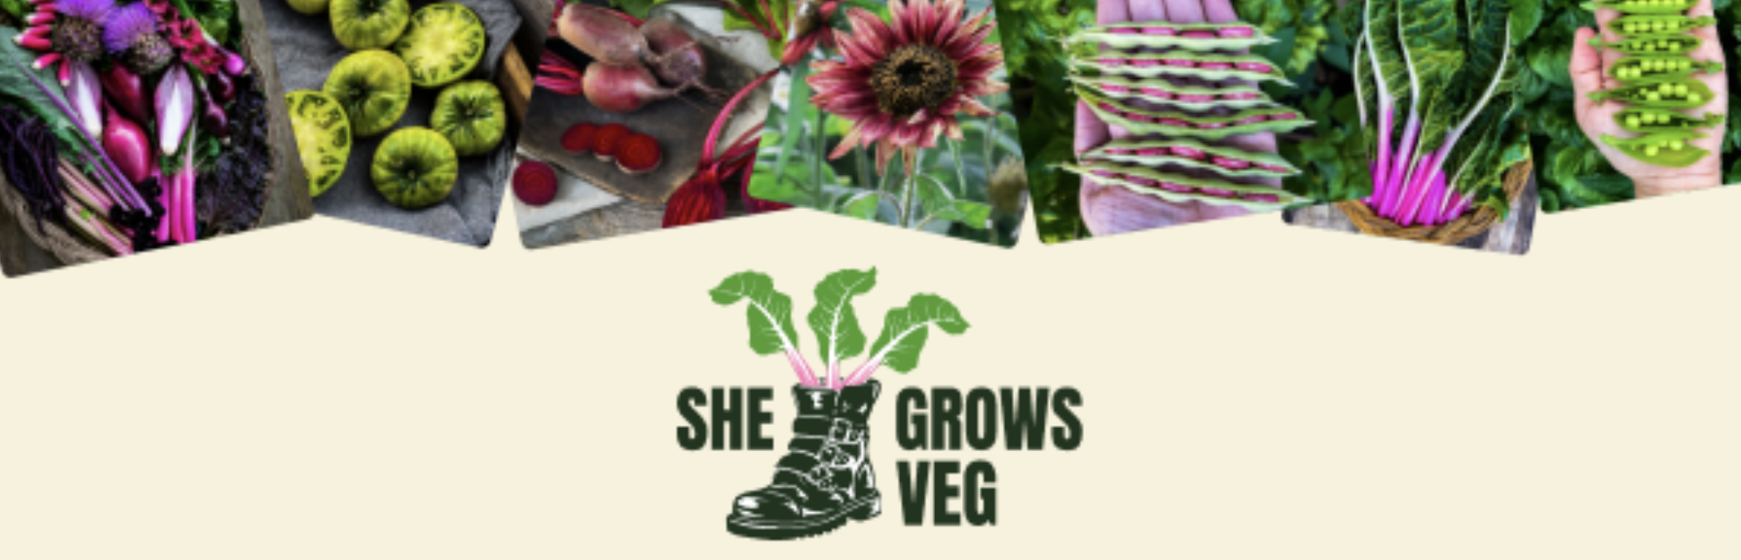
Our female founders Kate and Lucy believe that there is nothing more satisfying and good for the soul than harvesting food you’ve grown from seed.
We are on a mission to help as many people as possible to grow their own food and feel the joy! As well as the pleasure of growing, the financial, wellbeing and sustainability benefits are endless. But many people don’t know where to start.

https://shegrowsveg.com/
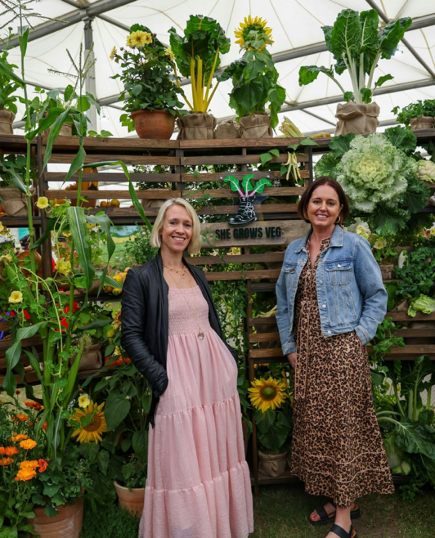
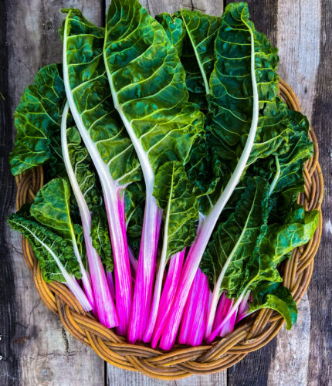

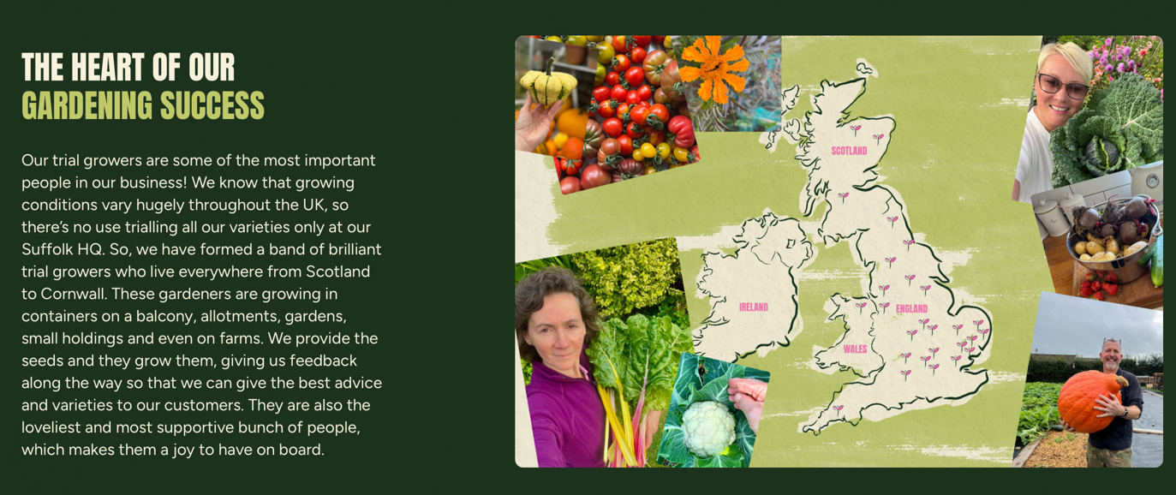
Wales Seed Hub,

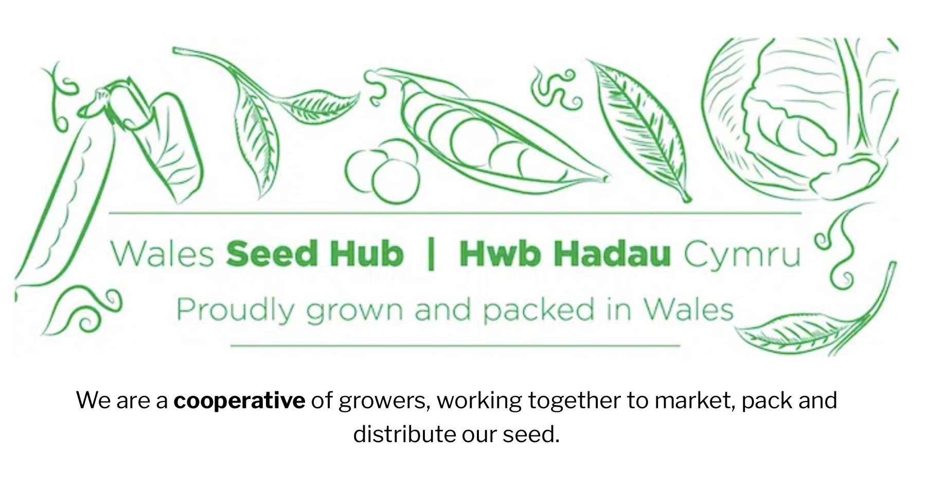
https://www.seedhub.wales
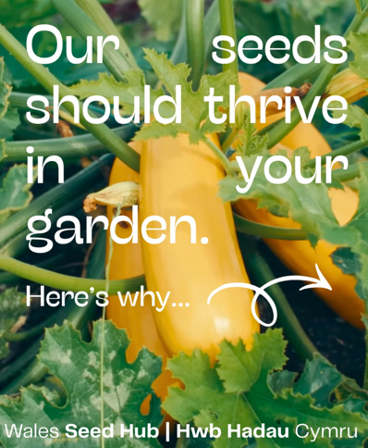
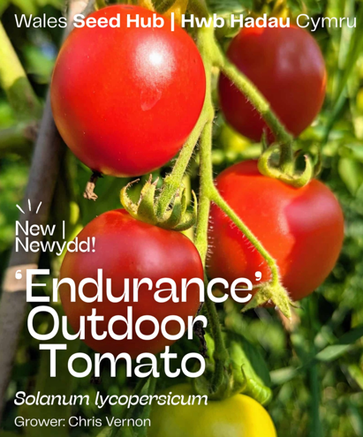
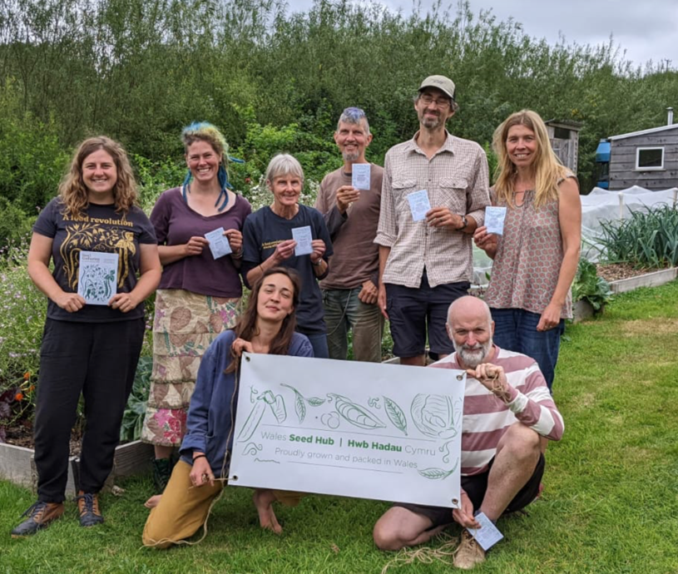
We are the Wales Seed Hub, a collective of individual growers who come together to co-operatively market and sell our seed. We are unique in that we only sell open pollinated seed that is produced in Wales to agroecological standards. We do not buy in seed for resale; all the seed we sell is grown by our members here in Wales, ensuring it is adapted to, and hence grows well in the local climate. We try and grow varieties that are not widely available elsewhere, and are always on the lookout for those with a Welsh history that we can grow on and preserve for future generations.
Our seed is sold online, and in person at various ‘seedy’ events we attend during the year. For more information on the Wales Seed Hub, and our members, heck us on our website, Facebook or Instagram

Bean and Herbs, “The Herbary”, 161 Chapel Street, Horningsham, Wiltshire BA12 7LU
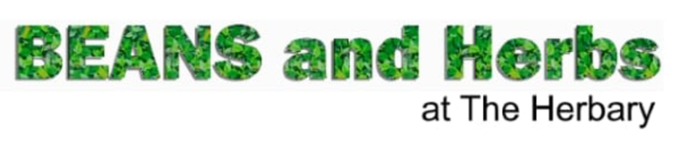
All vegetable and herb seed provided by our cultivation is organically produced. We have organic certification for seed production and marketing. We sell high quality organic seed at a reasonable price. For our catalogue we have chosen many varieties that are ideally suited to home-growing and have a long cropping season. All our seed is open pollinated seed so you can save your own seed from any of our varieties. We specialise in beans and herbs and continue to grow these in large numbers. We also now have a good range of organic flower seed.

https://www.beansandherbs.co.uk

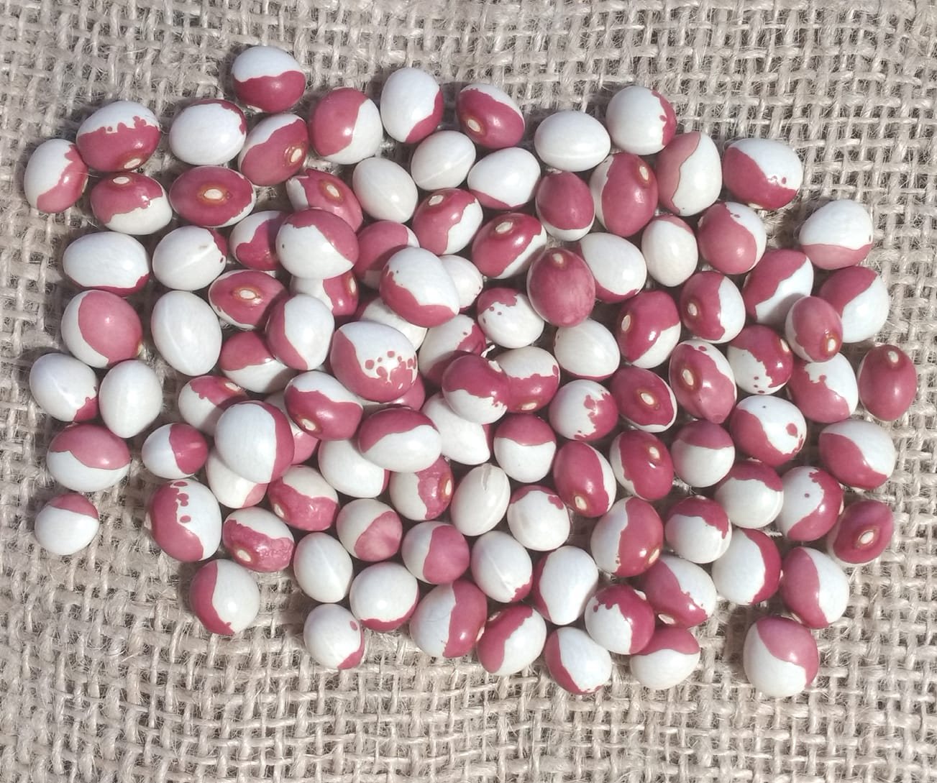
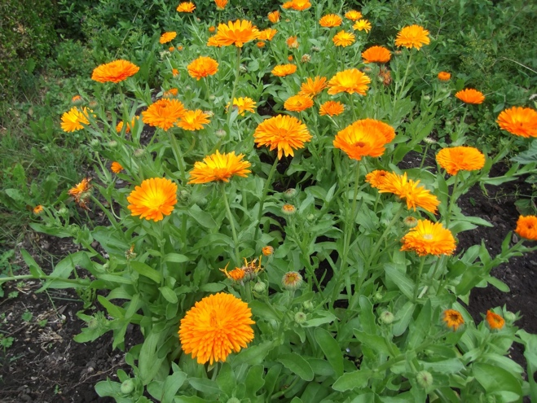
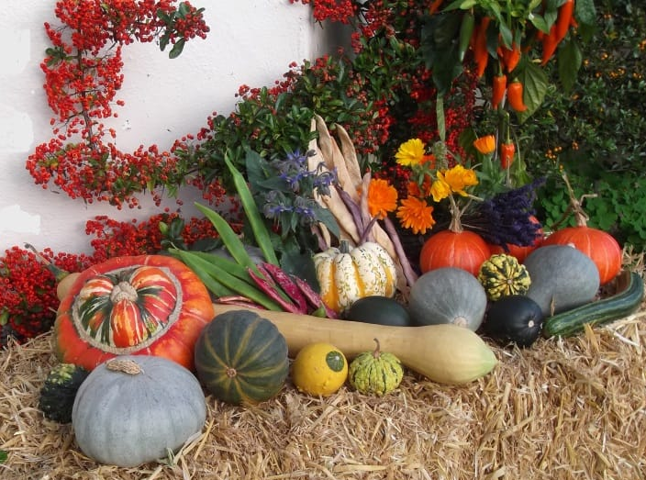

Possible the seed supplier who has been around for the longest by a decade or two!

She has a stand at the Seedy Saturday at Sat 14th March 2026 10am – 2pm Timsbury Congyre Hall, North Road, Timsbury, near Wellow BA2 0JQ Our stand – ORGANIC SEEDS for sale – organic Vegetable and Herb seed. Flower seed including wildflowers.

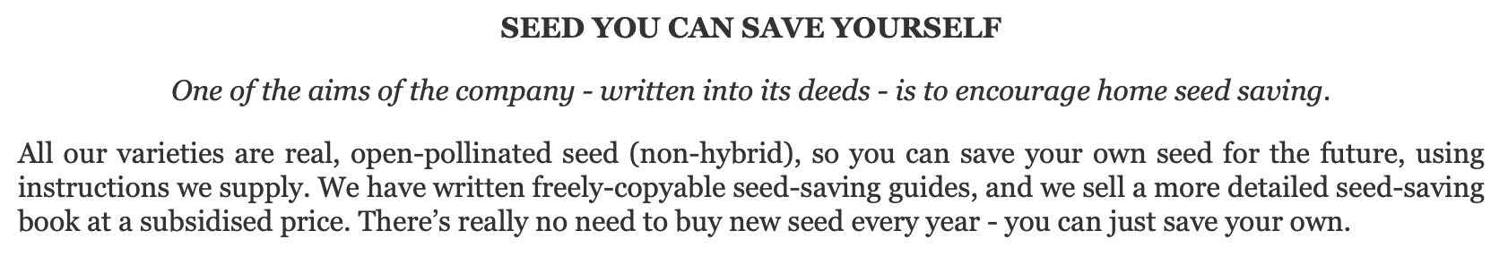
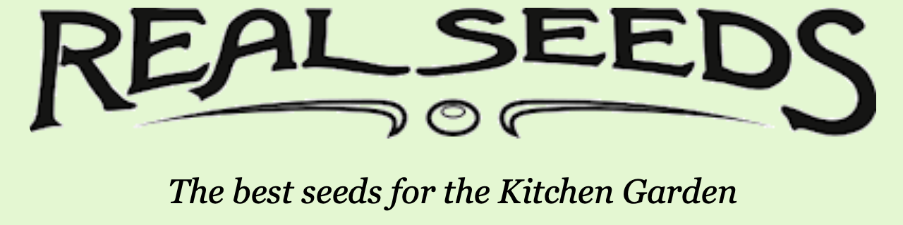
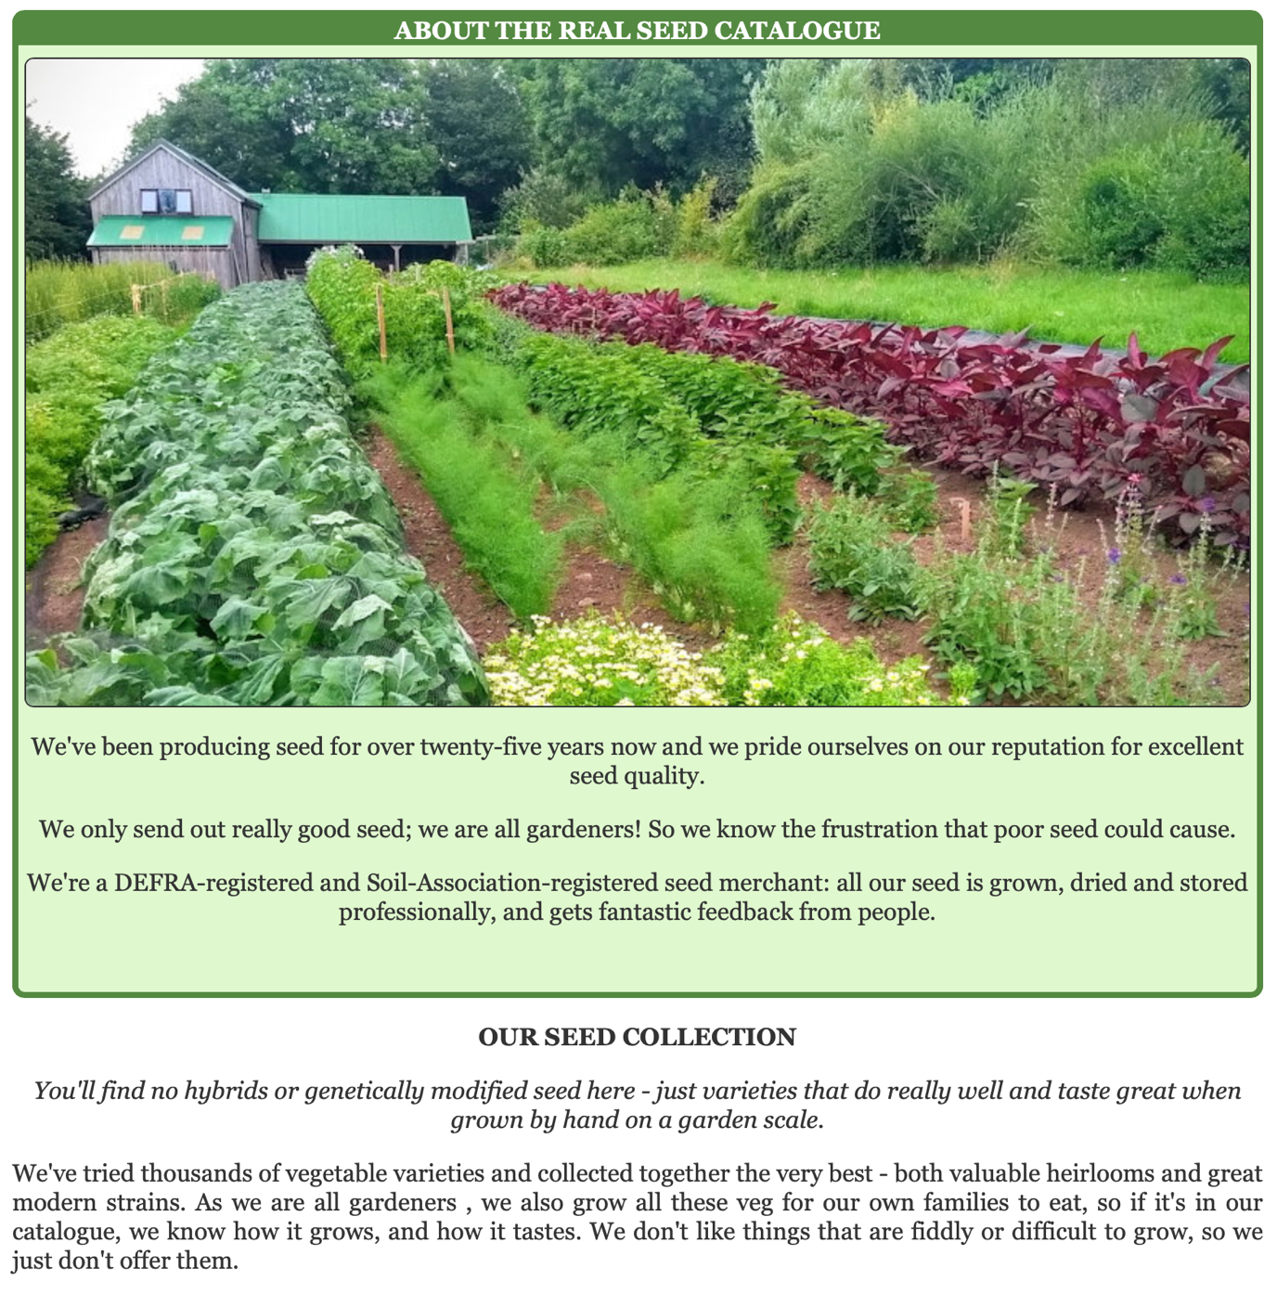
Real Seeds, Unit 4 Old School, Lower St Mary Street, Newport, SA42 0TS
https://realseeds.co.uk

